402

Dashboard Assignment

Overall Goal: Assess a volunteer’s desire, aptitude, and ability to serve in ministries throughout Wooddale Church.

Progression of thought, or logic: The dashboard should build from basic information such as member status, availability, current commitment/monthly attendance, location, area of passion, skills.

deep red at one end, to pink, to white in the center, to light blue, and then to deep blue at the other end

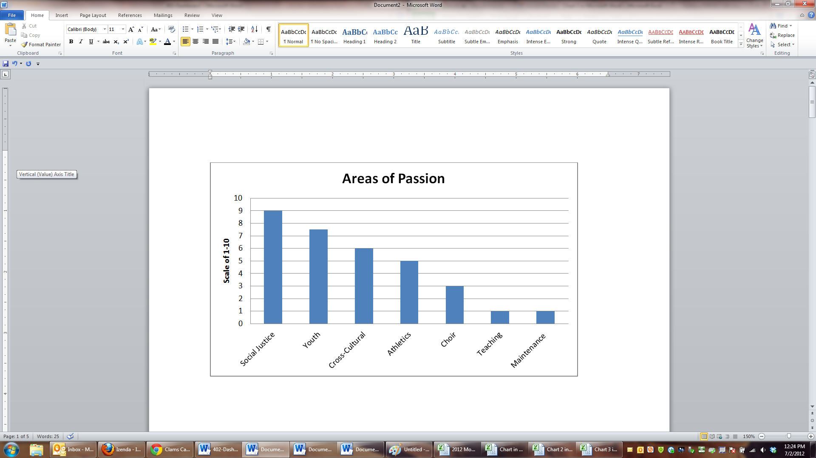

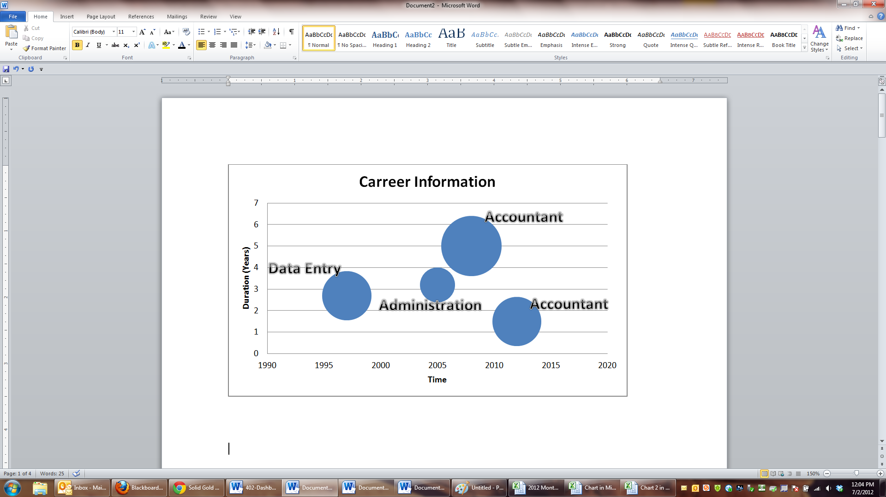

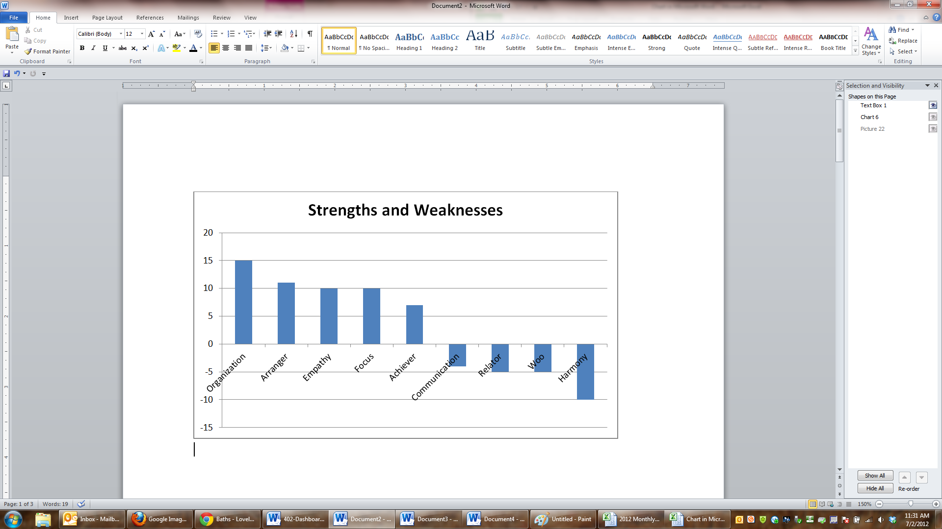

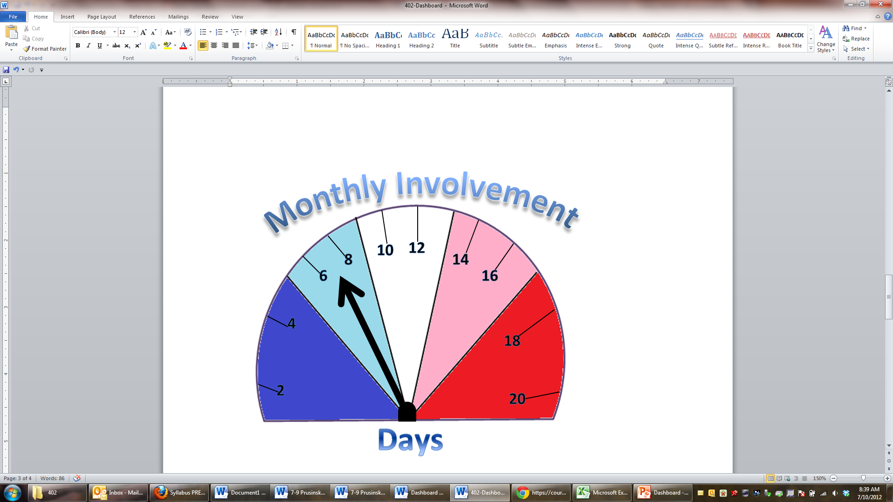

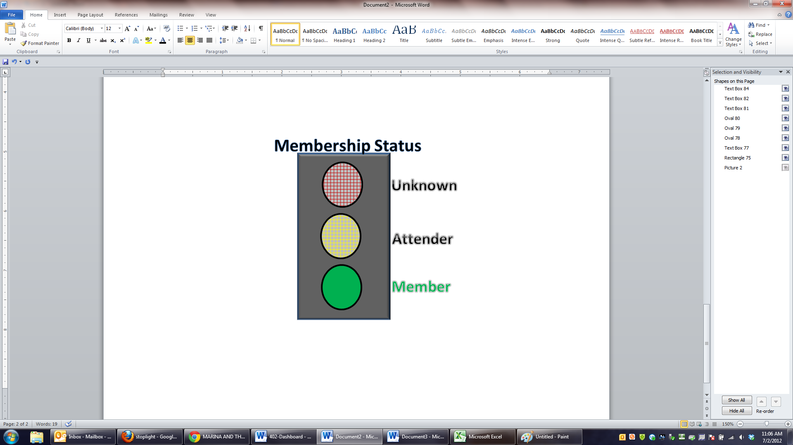

**Monthly Involvement**

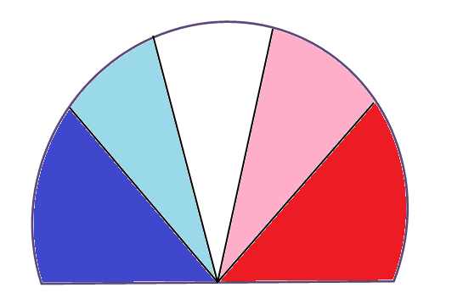

**20**

**18**

**16**

**14**

**12**

**10**

**8**

**6**

**4**

**2**

**Days**

**Unknow**

**Attender**

**Member**

**Membership Status**